

Faculty of Engineering

Department of Civil Engineering

2017-2018 Spring Semester

**CE 0337 Water Resources Management**

**Linear Programming and Irrigation Planning Homeworks by LINDO**

Prepared By  
1600006183 Tuğçe Altınkaynak

**Dr. K. Emre Can**

**1st Question**

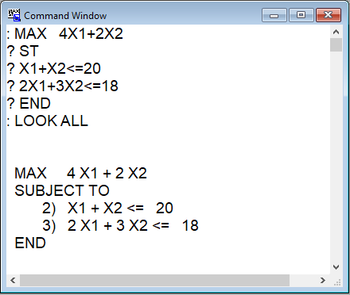

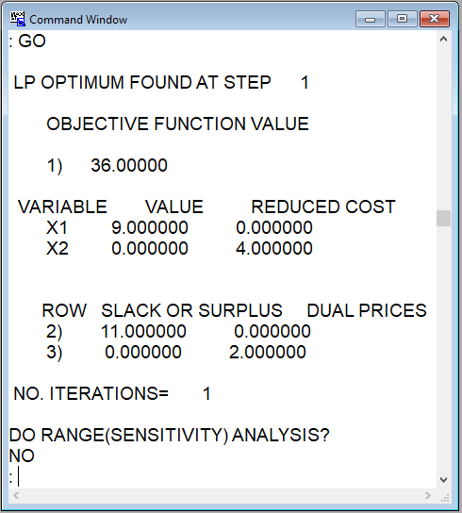

**2nd Question**

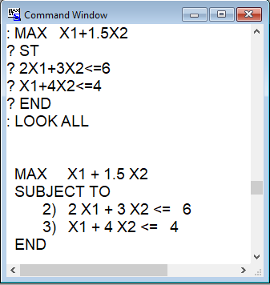

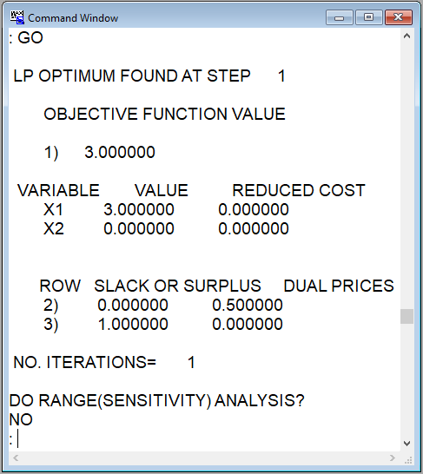

**3rd Question**

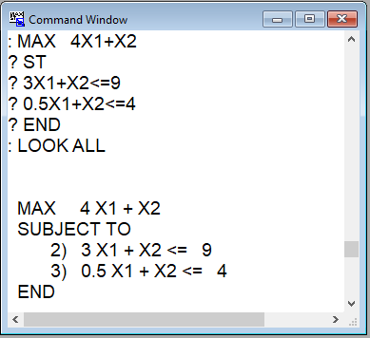

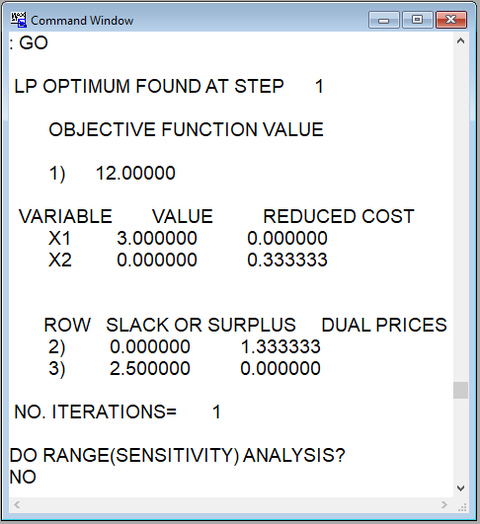

**4th Question**

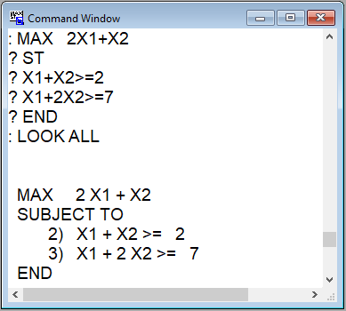

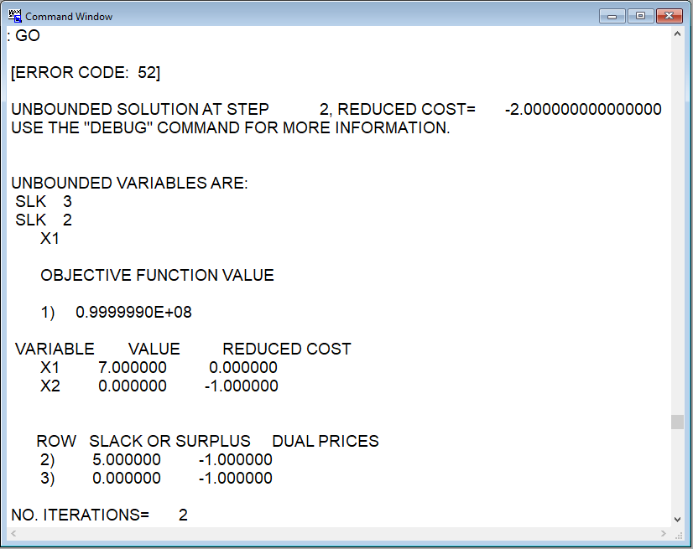

**5th Question**

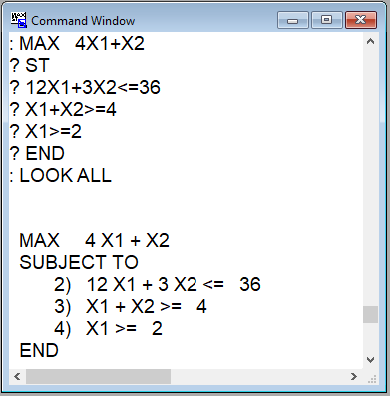

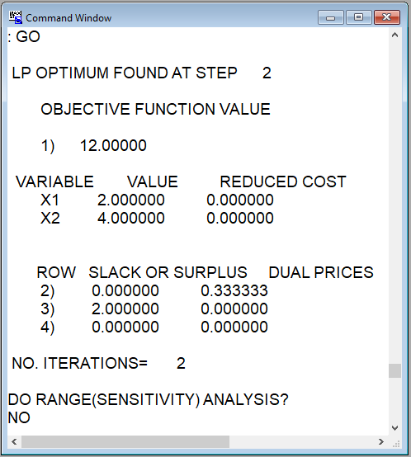

**6th Question (Irrigation Planning)**

|  |  |  |  |  |  |  |  |  |
| --- | --- | --- | --- | --- | --- | --- | --- | --- |
| X1 | X2 | X3 | X4 | X5 | X6 | X7 | X8 | X9 |
| ACotton1 | Arice | Amelons | Acitrus | Awheat | Acorn | Asesame | ACotton2 | ALima beans |

